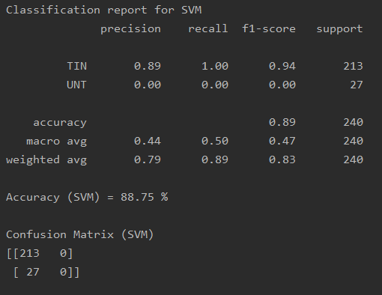

Classification report for SVM

precision recall f1-score support

TIN 0.89 1.00 0.94 213

UNT 0.00 0.00 0.00 27

accuracy 0.89 240

macro avg 0.44 0.50 0.47 240

weighted avg 0.79 0.89 0.83 240

Accuracy (SVM) = 88.75 %

Confusion Matrix (SVM)

[[213 0]

[ 27 0]]

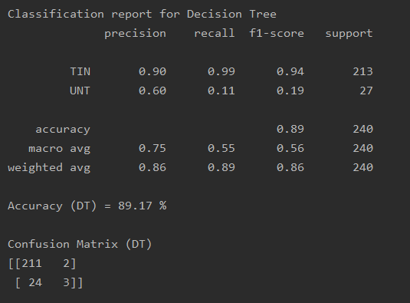

Classification report for Decision Tree

precision recall f1-score support

TIN 0.90 0.99 0.94 213

UNT 0.60 0.11 0.19 27

accuracy 0.89 240

macro avg 0.75 0.55 0.56 240

weighted avg 0.86 0.89 0.86 240

Accuracy (DT) = 89.17 %

Confusion Matrix (DT)

[[211 2]

[ 24 3]]

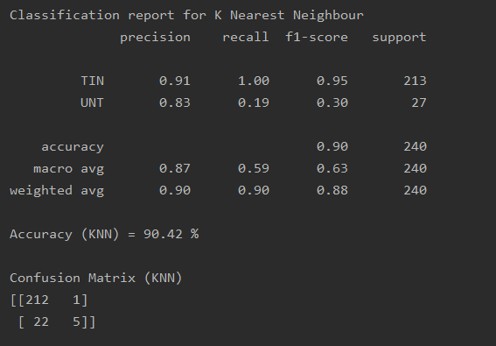

Classification report for K Nearest Neighbour

precision recall f1-score support

TIN 0.91 1.00 0.95 213

UNT 0.83 0.19 0.30 27

accuracy 0.90 240

macro avg 0.87 0.59 0.63 240

weighted avg 0.90 0.90 0.88 240

Accuracy (KNN) = 90.42 %

Confusion Matrix (KNN)

[[212 1]

[ 22 5]]

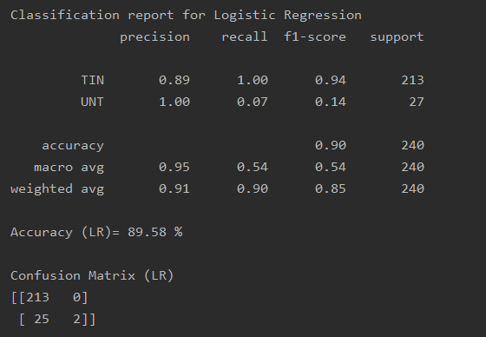

Classification report for Logistic Regression

precision recall f1-score support

TIN 0.89 1.00 0.94 213

UNT 1.00 0.07 0.14 27

accuracy 0.90 240

macro avg 0.95 0.54 0.54 240

weighted avg 0.91 0.90 0.85 240

Accuracy (LR)= 89.58 %

Confusion Matrix (LR)

[[213 0]

[ 25 2]]